* XML stands for extensible mark up language.
* XML is used to store data and to transport the data.
* In XML , we can define our own tags.

The XML syntax rules are

1. XML tags , attributes are case-sensitive.
2. XML tags must be paired tags.
3. XML tags must properly be nested.
4. Attribute values must be written inside a single /double quotes.
5. …etc

**1.Well-Formed XML Document:-**If XML document is satisfying syntax rules , then that document is called “**WELL-FORMED XML document**”.

Example: student.xml

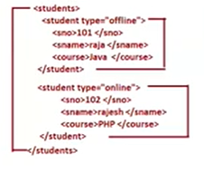

The student. xml document that satisfies syntax rules(above said) is called “well-formed xml document”.

**2.Valid XML Document:-** The technology / framework vendors gives certain rule in the form of **DTD(.dtd file) or XSD(.xsd file)** Documents.

DTD means Document Type Definition.(old)

XSD means xml Schema Definition.(new)

The developer should import DTD rules or XSD rules in .xml file in order to create xml document based on imported DTD rules or XSD rules.

The rules are

* Tags are allowed
* Attributes that are allowed in each tag.
* Structure of tags( which tags should be used in which order and where)
* ...etc.

If xml document is satisfying the imported rules then it is called “valid XML document”.

Q) why does technology/framework vendor provides rules?

A) Application developers of same technology(servlet) uses their own/choice tags and attribute to configure . Then servlet container is unable to understand the meaning and purpose of tags. Therefore vendor of servlet container gives rule book in the form DTD or XSD .

All developers will be forced to use same tags and attributes in deployment descript file.

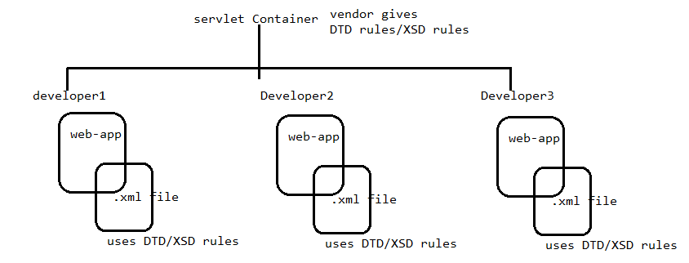

**XML Parser:-**The **XML parser is software application**. It is used to Load, read the xml file data and verifies it well-formed,valid or not.

EX: DOM4J parser, SAX parser …etc.

After verifies xml document is well-formed or not, xml parser prepares In-Memory Meta Data.

The servlet container uses their own xml parser (Mostly SAX parser) . This parser prepares **IN-Memory Meta Data Of web.xml file** in JVM memory of RAM where web container/servlet container is running.

In-Memory meta data of xml file contains the content of web.xml file and other related information in the form of objects. These objects are immutable.

In-Memory Meta Data is created only one time during web-app starting. The web-app uses In-memory Meta Data fastly as many times the web-application needs to during execution.

